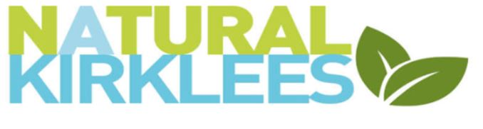Internet and Email Usage policy
Natural Kirklees can provide a specific email to all trustees and volunteers for the use of communicating on behalf of Natural Kirklees, free of charge. Anyone sending emails or other communication via the internet do so on the understanding they may only act within any agreed and documented authority and in a manner that would be expected in a face-to-face conversation or written document and within Natural Kirklees policies.
Examples of what is considered unacceptable usage, but not an exclusive list is
- Creation or transmission of material which brings the Natural Kirklees into disrepute.
- Creation or transmission of material that is illegal.
- The transmission of unsolicited commercial or advertising material, chain letters, press releases or other junk-mail of any kind
- The unauthorised transmission to a third party of confidential material concerning the activities of Natural Kirklees.
- The transmission of material such that this infringes the copyright of another person, including intellectual property rights.
- Activities that corrupt or destroy other users' data or disrupt the work of other users.
- Creation or transmission of any offensive, obscene or indecent images, data or other material.
- Creation or transmission of material which is designed or likely to cause annoyance, inconvenience or anxiety.
- Creation or transmission of material that is abusive or threatening to others, serves to harass or bully others, discriminates or encourages discrimination on racial or ethnic grounds, or on grounds of gender, sexual orientation, marital status, disability, political or religious beliefs.
- Creation or transmission of defamatory material or material that includes claims of a deceptive nature.
- Activities that violate the privacy of others or unfairly criticise or misrepresent others.
- Creation or transmission of anonymous messages or deliberately forging messages or email header information, (i.e., without clear identification of the sender) or for 'flaming'.
- The unauthorised provision of access to Natural Kirklees data or facilities by third parties.
Signed Ed Day – Chair of the Trustees
Policy Date – 1st September 2022 Review Date September 2023

