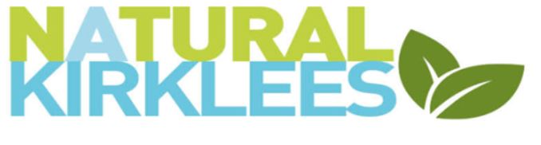
NATURAL KIRKLEES RESERVES POLICY
Introduction
Natural Kirklees is funded primarily by Kirklees Council under a 3-year agreement which will either terminate or be renewed in October 2025. In as much as anything can be guaranteed, the agreement provides funding for the 3-year period. The funding provided for the provision of public liability insurance for eligible members, the loan of tools from our tool stores, the maintenance of a web site, detailing our members and grants for eligible members.
Reserves
The ongoing support to members by way of providing public liability insurance is seen as the prime financial aspect of Natural Kirklees role. Should the council be in a position where they cannot provide adequate funding, Natural Kirklees is unlikely to be able to raise sufficient funds by other means. The trustees therefore aim to maintain free reserves in unrestricted funds at a level which equates to two years of unrestricted charitable expenditure in relation to the insurance costs and general administration. The trustees consider that this level will provide sufficient funds to respond to the cost of the insurance for those members covered at the time of any failure of the agreement with the council and ensure that support and governance costs are covered.
The balance held as free reserves within unrestricted funds at 30 September 2022 will be set at £25,000 and will ensure insurance cover is provided up to 19th September 2025.

Signed

Ed Day - Chair

Julie Hirst - Treasurer

Policy Dated 30th September 2022 – review date September 2023

